**STATIONS OF THE CROSS**

**Anon (1)**

*Tonight’s ‘Stations of the Cross’ begins in the Lady Chapel.*

**Introduction and opening prayer**

Leader 1: In the name of the Father and of the Son and of the Holy Spirit. **Amen**

Life is a spiritual journey. Sometimes we move forward and sometimes we don’t. We all make mistakes, but by the grace of God, we learn from those moments when we get it wrong and then start to move forward again.

As children, we have a particular perspective on life. As adults, we develop. But we should never lose sight of our early insights as they are important stepping stones on the way that leads to salvation.

Tonight, as we walk the Way of the Cross, let us reflect on the way that the different parts of our lives inform us and use those moments to discern where our Lord is leading us.

*Leader 5: Let us pray:*

*Lord God, we are about to walk with your Son through the stages of his suffering and death. We know that Jesus’ sacrifice gave us the name Christian. We know that Jesus saved us and brought us new life through his sacrifice on the cross and his rising from the dead three days later.*

*Help us to understand a little better and to love a little more.*

*Help us to live less selfish lives.*

*Open our minds to help us see how we can better follow in Jesus’ footsteps.*

*We ask this through Christ our Lord.* ***Amen***

Leader 1: Let us walk with Christ the Way that leads to life.

## Please move to the First Station as we sing:

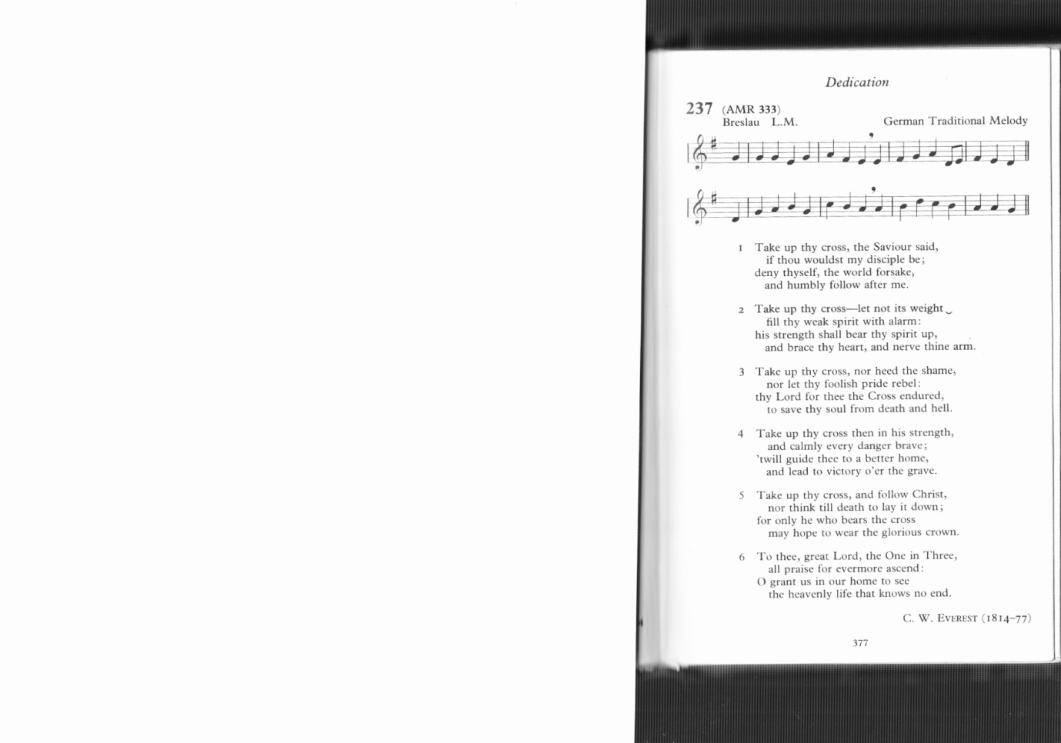

TakTake up thy cross, the Saviour said,

if thou wouldst my disciple be;

deny thyself, the world forsake,

and humbly follow after me.

Take up thy cross: let not its weight

fill thy weak spirit with alarm;

his strength shall bear thy spirit up,

and brace thy heart, and nerve thine arm.

# Leader 1: (1) JESUS IS CONDEMNED TO DEATH

Leader 1: We adore you, O Christ, and we bless you

All: For by your cross, you have redeemed and saved us.

Leader 2: Jesus, you stand all alone before Pilate. Nobody speaks up for you. Nobody helps defend you. You devoted your entire life to helping others, listening to the smallest ones, caring for those who were ignored by others. They don’t seem to remember that as they put you to death.

*Leader 3:**As a child, sometimes I feel alone. Sometimes I feel that others don’t stand up for me and defend me when I am afraid. Sometimes I don’t feel like I’m treated fairly, especially if I am scolded or corrected.*

Leader 4: As an adult, sometimes I feel abandoned and afraid as well. Sometimes I too, feel like I am treated unfairly or blamed for things unfairly. I have a hard time when people criticize me at home or at work.

Help me be grateful for what you did for me. Help me to accept criticism and unfairness as you did, and not complain. Help me pray for those who hurt me.

*Leader 5: Father God, many times people don’t seem to understand me. Sometimes too, I feel like the criticism of others is unfair Help me to accept the mistakes of others as you accept me when I make mistakes. Help me be big enough to ask forgiveness for the mistakes I make and forgive as Jesus did. Through Christ our Lord.* ***Amen***

**All: I love you Jesus, my love, above all things. I repent with my whole heart for having offended you; never permit me to separate myself from you again. Grant that I may love you always – and then do with me what you will.**

Take up thy cross, nor heed the shame,

nor let thy foolish pride rebel:

thy Lord for thee the cross endured,

to save thy soul from death and hell.

# Leader 1: (2) JESUS TAKES UP HIS CROSS

Leader 1: We adore you, O Christ, and we bless you

All: For by your cross, you have redeemed and saved us.

Leader 2 Jesus, as you accepted your cross, you knew you would carry it to your death on Calvary. You knew it wouldn’t be easy, but you accepted it and carried it just the same.

*Leader 3: As a child, sometimes I don't like the problems that come my way Sometimes I try to get others to take care of them or solve them for me. Sometimes I become upset or crabby when I’m asked to do even the smallest thing to help others.*

Leader 4: As an adult, I sometimes feel I’m not appreciated. Sometimes I feel as if I accept more responsibility that I need to. I can feel sorry for myself, even though the crosses others carry are much larger than my own. In my self-pity, I don’t reach out to help.

*Leader 5: Father God, my problems may seem small to those around me, but you know how hard they are to carry sometimes. Help me remember and pray for those who are handicapped and those whose problems are severe. When I’m tempted to complain, help me remember Jesus and the cross he carried for me. Through Jesus Christ our Lord.* ***Amen.***

**All: I love you Jesus, my love, above all things. I repent with my whole heart for having offended you; never permit me to separate myself from you again. Grant that I may love you always – and then do with me what you will.**

Take up thy cross then in his strength,

and calmly every danger brave;

’twill guide thee to a better home,

and lead to victory o’er the grave.

# Leader 1: (3) JESUS FALLS THE FIRST TIME

Leader 1: We adore you, O Christ, and we bless you

All: For by your cross, you have redeemed and saved us.

Leader 2: Jesus, the cross you have been carrying is very heavy. You are becoming weak and almost ready to faint, and you fall down. Nobody seems to want to help you. The soldiers are only interested in getting home, so they yell at you and try to get you up and moving again.

*Leader 3: As a child, sometimes I start to do something, but then get tired of it. I hurry to get finished and sometimes don’t do my work well. Sometimes I don’t pay attention to what I should be doing. When things get hard for me, sometimes I give up.*

Leader 4: As an adult, I sometimes put things off. I give up too easily, and sometimes don’t do my work as well as I know I can.

*Leader 5: Father God, I know there are many times when I give up before I should. I need to think of the cross Jesus carried, and how he got up again and kept moving. Help me to do my work as well as I can and to finish what I have started. When I fall, help me get up again and keep going. Through Jesus Christ our Lord.* ***Amen***

**All: I love you Jesus, my love, above all things. I repent with my whole heart for having offended you; never permit me to separate myself from you again. Grant that I may love you always – and then do with me what you will.**

Take up thy cross, and follow Christ,

nor think till death to lay it down;

for only they who bear the cross

may hope to wear the glorious crown.

# Leader 1: (4) JESUS MEETS HIS MOTHER

Leader 1: We adore you, O Christ, and we bless you

All: For by your cross, you have redeemed and saved us.

Leader 2: Jesus you feel so alone with all these people yelling and screaming at you. You don’t like the words they are saying about you, and you look for a friendly face in the crowd. You see your mother. She can’t make the hurting stop, but it helps to see that she is on your side, that she is suffering with you. She does understand and care.

*Leader 3: As a child, I often feel that too many things are going on. Other kids pick on me and call me names. I need to look around for a friendly face, and for the help I need. I need to share my troubles with those who truly care about me.*

Leader 4: As an adult, I sometimes feel overwhelmed by many things. Life is so competitive, and I worry so much about my future and those who have control over it. I need to remember that being an adult does not mean having to solve every problem all by myself. I need to look around me for a friendly face; for the help I need.

*Leader 5: Father God, you gave me parents. Nobody can ever take their place. I thank you for that gift. Help me to show my love and appreciation to them. Help me to remember to pray for them. If they have died, help me be challenged by the love they shared with me. When I feel alone, help me to realize that you are my parent, the friendly face that I can depend upon to give the help that I need. Through Jesus Christ our Lord.* ***Amen***

**All: I love you Jesus, my love, above all things. I repent with my whole heart for having offended you; never permit me to separate myself from you again. Grant that I may love you always – and then do with me what you will.**

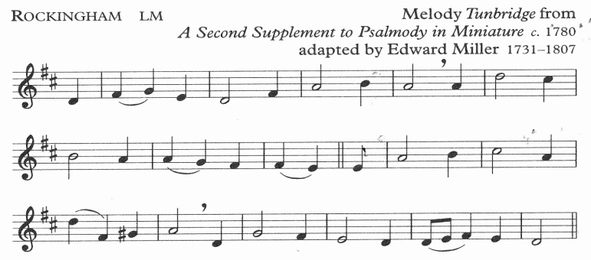

When I survey the wondrous cross

on which the prince of glory died,

my richest gain I count but loss,

and pour contempt on all my pride.

# Leader 1: (5) SIMON OF CYRENE HELPS JESUS CARRY HIS CROSS

Leader 1: We adore you, O Christ, and we bless you

All: For by your cross, you have redeemed and saved us.

Leader 2: Jesus, the soldiers are becoming impatient. This is taking longer than they wanted it to. They are afraid you won’t make it to the hill where you will be crucified. As you grow weaker, they grab a man out of the crowd and make him help you carry your cross. He was just watching what was happening, but all of a sudden he is helping you carry your cross.

*Leader 3: As a child, I see people who need my help. Sometimes I pretend not to hear when my parents call me. I disappear when I know others could use my help.*

Leader 4: As an adult, I try to do as little as I can and still get by. Others might need my help, but I ignore their needs. Even when I’m asked to help, I sometimes claim to be too busy.

*Leader 5: Father God, help me notice the needs of those around me. Help me to do more than just stand there and watch. Help me to see the needs of others as opportunities for me to reach out and help as you did. Through Jesus Christ our Lord.* ***Amen***

**All: I love you Jesus, my love, above all things. I repent with my whole heart for having offended you; never permit me to separate myself from you again. Grant that I may love you always – and then do with me what you will.**

Forbid it, Lord, that I should boast

save in the cross of Christ my God;

all the vain things that charm me most,

I sacrifice them to his blood.

# Leader 1: (6) VERONICA WIPES THE FACE OF JESUS

Leader 1: We adore you, O Christ, and we bless you

All: For by your cross, you have redeemed and saved us.

Leader 2: Jesus, suddenly a woman comes out of the crowd. Her name is Veronica. You can see how she cares for you as she takes a cloth and begins to wipe the blood and sweat from your face. She can’t do much, but she offers what she little help she can.

*Leader 3: As a child, there are times when I know someone could use a little help and understanding. They may be picked on or teased by others, or just sad or lonely. Sometimes I feel bad that others don’t step in to help, but I don’t help either.*

Leader 4: As an adult, I notice the needs around me. Sometimes my own family members crave my attention, and I don’t even seem to notice. Sometimes a co-worker, friends or member of my family could use help or understanding but I don’t reach out to help lest I be criticized, or that they demand more of me than I’d like to give.

*Leader 5: Father God, help me to see the needs of others as being as important as my own needs. Remind me to go out of my way to be helpful, even when I’m not asked. Help me not to be concerned about what others may think of me. Through Jesus Christ our Lord.* ***Amen***

**All: I love you Jesus, my love, above all things. I repent with my whole heart for having offended you; never permit me to separate myself from you again. Grant that I may love you always – and then do with me what you will.**

See from his head, his hands, his feet,

sorrow and love flow mingled down;

did e’er such love and sorrow meet,

or thorns compose so rich a crown!

# Leader 1: (7) JESUS FALLS FOR THE SECOND TIME

Leader 1: We adore you, O Christ, and we bless you

All: For by your cross, you have redeemed and saved us.

Leader 2: This is the second time you have fallen on the road. As the cross grows heavier and heavier it becomes more difficult to get up. But you continue to struggle and try until you’re up and walking again. You don’t give up.

*Leader 3: As a child, there are times when things get me down. Others seem to find things easier to do or to learn. Each time I fail, I find it harder to keep trying.*

Leader 4: As an adult, I think I should know more than I do. I become impatient with myself and find it hard to believe in myself when I fail. It is easy to despair over small things, and sometimes I do.

*Leader 5: Father God, life can be hard. Sometimes I grow impatient with myself, and even take that impatience out on others. Help me realize how much you love me, just as I am. Help me to keep trying when things get hard and when I fall, just like Jesus did. Through Jesus Christ our Lord.* ***Amen***

**All: I love you Jesus, my love, above all things. I repent with my whole heart for having offended you; never permit me to separate myself from you again. Grant that I may love you always – and then do with me what you will.**

His dying crimson, like a robe,

spreads o’er his body on the tree:

then am I dead to all the globe,

and all the globe is dead to me.

# Leader 1: (8) JESUS SPEAKS TO THE WOMEN OF JERUSALEM

Leader 1: We adore you, O Christ, and we bless you

All: For by your cross, you have redeemed and saved us.

Leader 2: Jesus, as you carry your cross, you see a group of women along the road. As you pass by, you see them weeping. You stop to spend a moment with them, to offer them some encouragement. Although you have been abandoned by your friends and are in pain, you stop and try to help them.

*Leader 3: As a child, I sometimes think a lot about myself. I think about what I want and would like people to spend their lives pleasing me.*

Leader 4: As an adult, I there are many times when I act like a child. I become so absorbed in myself and what I’d like that I forget about the needs of others. I take them for granted, and often ignore their needs.

*Leader 5: Father God, many times I am selfish. I expect others to serve me while doing very little for them. Help me to notice and respond to the needs others have, even when I have problems of my own. Through Jesus Christ our Lord.* ***Amen***

**All: I love you Jesus, my love, above all things. I repent with my whole heart for having offended you; never permit me to separate myself from you again. Grant that I may love you always – and then do with me what you will.**

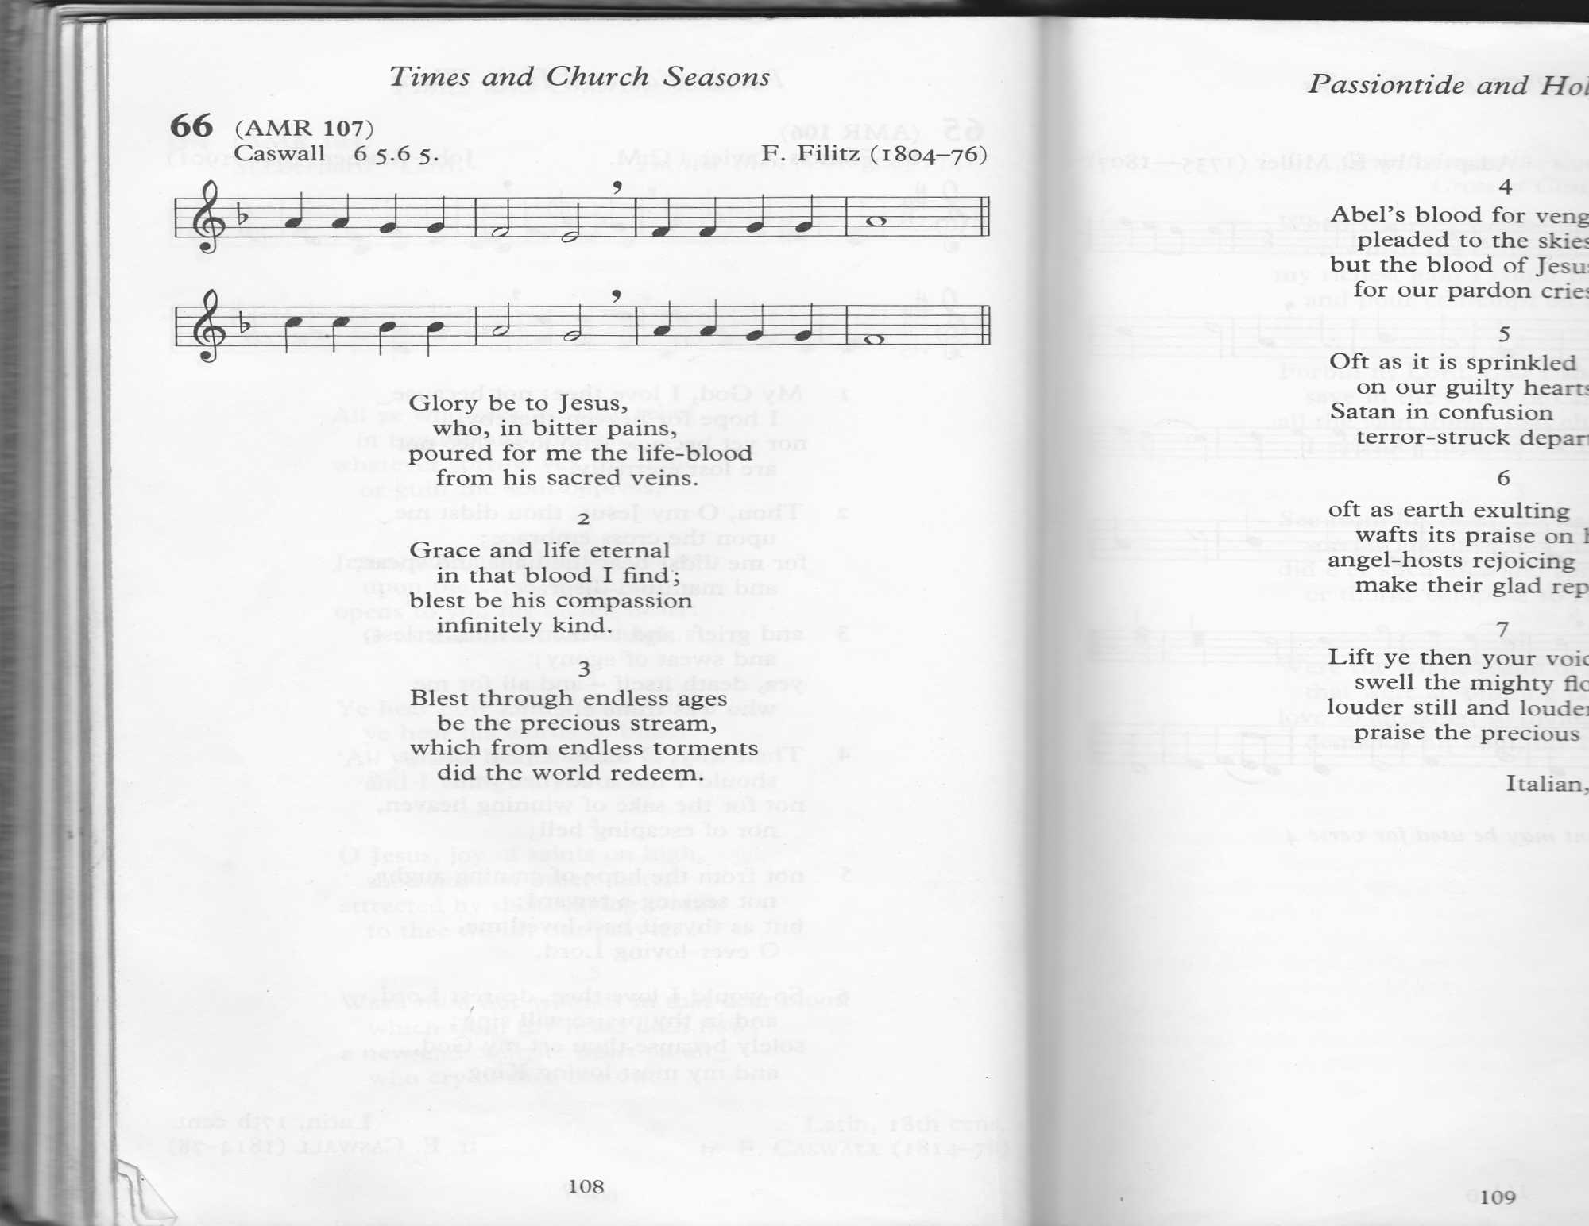

Glory be to Jesus,

who, in bitter pains,

poured for me the life-blood

from his sacred veins.

# Leader 1: (9) JESUS FALLS THE THIRD TIME

Leader 1: We adore you, O Christ, and we bless you

All: For by your cross, you have redeemed and saved us.

Leader 2: Jesus, your journey has been long. You fall again, beneath your cross. You know your journey is coming to an end. You struggle and struggle. You get up and keep going.

*Leader 3: As a child, I fail time and again. I find it harder to get along with my brothers and sisters; sometimes I’m not honest; sometimes I’m lazy. I’m tempted to stop trying. It’s just too hard sometimes.*

Leader 4: As an adult, I feel that that I should have conquered my weaknesses by now. I become discouraged when I am confronted by the same problems over and over again. Sometimes I get weary. When I have health problems, I can become discouraged and depressed.

Help me think of the cross you carried. Help me continue to hope that I can make the changes in my life I need to. You didn’t give up. I can have the strength to get up again as well.

*Leader 5: Father God, many times I feel like giving up. .Sometimes I grow impatient with myself, especially when I make the same mistakes over and over again. Help me use this awareness to become more compassionate towards others. Help me to get up and keep going, as Jesus did. Through Jesus Christ our Lord.* ***Amen***

**All: I love you Jesus, my love, above all things. I repent with my whole heart for having offended you; never permit me to separate myself from you again. Grant that I may love you always – and then do with me what you will.**

Grace and life eternal

in that blood I find;

blest be his compassion

infinitely kind.

# Leader 1: (10) JESUS IS STRIPPED OF HIS GARMENTS

Leader 1: We adore you, O Christ, and we bless you

All: For by your cross, you have redeemed and saved us.

Leader 2: The soldiers notice you have something of value. They remove your cloak and throw dice for it. Your wounds are torn open once again. Some of the people in the crowd make fun of you. They tease you and challenge you to perform a miracle for them to see. They’re not aware that you’ll perform the greatest miracle of all.

*Leader 3: As a child, I find myself tempted to repeat stories that are unclean and disrespectful. I sometimes try to act grown up by using crude and bad words.*

Leader 4: As an adult, I repeat stories that are disrespectful of others. I can entertain thoughts that are not clean. Sometimes I give the young people around me a bad example to follow.

*Leader 5: Father God, help me to be aware of the prejudices I have against others. Help me value those around me, rather than degrading them by telling unclean stories. Help me strive to be pure in my thoughts, words and deeds... Through Jesus Christ our Lord.* ***Amen***

**All: I love you Jesus, my love, above all things. I repent with my whole heart for having offended you; never permit me to separate myself from you again. Grant that I may love you always – and then do with me what you will.**

Blest through endless ages

be the precious stream,

which from endless torments

did the world redeem.

# Leader 1: (11) JESUS IS NAILED TO THE CROSS

Leader 1: We adore you, O Christ, and we bless you

All: For by your cross, you have redeemed and saved us.

Leader 2: You are stretched out on the cross you have carried so far. The soldiers take big nails and drive them into your hands and feet. You feel abandoned by the people you loved so much. People seem to have gone mad. You have done nothing but good, yet they drive nails through your hands and feet.

*Leader 3: As a child, there are times when I hurt others. Sometimes I join with friends and decide not to like another. We gang up against another and cause them hurt and pain. Sometimes I say or do hurtful things to my sisters or brothers. I can wonder what they’d think about themselves if they believed everything I told them about themselves*

Leader 4: As an adult, I discriminate against others. Even without thinking, I judge others because of their colour, intelligence, income level or name. I forget that I am to live as a brother or sister to all people. Sometimes I use harsh words when I speak to my children or someone in my family. I can find it easy to look for something that isn’t very important and make it very important.

Help me to look at the people around me. Help me to see the hurt and pain I have caused in others. Be with me to help me make amends for the harm I have done.

*Leader 5: Father God, I act too often without thinking. I can be easily led, just like the soldiers and the crowd that put Jesus to death. Never let me drive a nail into another by my prejudice or hatred. Through Jesus Christ our Lord.* ***Amen***

**All: I love you Jesus, my love, above all things. I repent with my whole heart for having offended you; never permit me to separate myself from you again. Grant that I may love you always – and then do with me what you will.**

Abel’s blood for vengeance

pleaded to the skies;

but the blood of Jesus

for our pardon cries.

***Walk TWO stations (omit 12 Jesus speaks to his Mother) to:***

# Leader 1: (13) JESUS DIES ON THE CROSS

Leader 1: We adore you, O Christ, and we bless you

All: For by your cross, you have redeemed and saved us.

Leader 2: As Jesus hung on the cross, he forgave the soldiers who had crucified him, and prayed for his mother and friends. Jesus wanted all of us to be able to live forever with God, so he gave all he had for us.

Jesus, let me take a few moments now to consider your love for me. Help me thank you for your willingness to go to your death for me. Help me to express my love for you.

*After a short pause:*

**All: I love you Jesus, my love, above all things. I repent with my whole heart for having offended you; never permit me to separate myself from you again. Grant that I may love you always – and then do with me what you will.**

Oft as it is sprinkled

on our guilty hearts,

Satan in confusion

terror-struck departs.

.

# Leader 1: (14) JESUS IS TAKEN DOWN FROM THE CROSS

Leader 1: We adore you, O Christ, and we bless you

All: For by your cross, you have redeemed and saved us.

Leader 2: Jesus, how brutally you were put to death. How gently you are taken down from the cross. Your suffering and pain are ended, and you are put in the lap of your mother. The dirt and blood are wiped away. You are treated with love.

*Leader 3: As a child, sometimes I treat others better when they’re sad or in pain. When somebody dies, I become very gentle and kind. I notice the good and kind things people say about those who have died.*

Leader 4: As an adult, I seem to be kinder when someone dies. If only I could learn to see the good things about them while they are alive... If only I would tell those around me how much I love them, while I still have the opportunity to do so.

Help me to look for the good in those around me, especially those I love the most. Help me to live this day as though it were my last. Help me become a more gentle and loving person through my greater appreciation for those around me.

*Leader 5: Father God, I never know how many more days I will live. Perhaps it will be many years, perhaps not too many days. Help me to make this a better day for those around me. Help me say kind things to the ones I love while they are with me, and while I am with them. It can make my life fuller and their lives happier when I do. Through Jesus Christ our Lord.* ***Amen***

**All: I love you Jesus, my love, above all things. I repent with my whole heart for having offended you; never permit me to separate myself from you again. Grant that I may love you always – and then do with me what you will.**

Oft as earth exulting

wafts its praise on high,

angel-hosts rejoicing

make their glad reply.

# Leader 1: (15) JESUS IS LAID IN THE TOMB

Leader 1: We adore you, O Christ, and we bless you

All: For by your cross, you have redeemed and saved us.

Leader 2: Jesus, your body is prepared for burial. Joseph gave you his own tomb. He laid your body there and rolled a large stone in front of it, then went home. What a sad day it had been for so many people.

*Leader 3: As a child, sometimes I try to keep everything for myself. I find it hard to share my things with my brothers and sisters and with my friends.*

Leader 4: As an adult, I can be selfish too. I can accumulate things and keep them for myself. I try to make sure that I have what I want before I share what I have with anybody else.

Help me to think of Joseph of Arimathea, who risked his own life as he accepted Jesus’ body for burial. Help me to think how Joseph loved Jesus so much that he gave him his own tomb.

*Leader 5: Father God, how uncomfortable it can make me to see the loving and generous way Jesus gave all he had for me. How selfish I can feel to hear of the generosity of Mary, Simon, Veronica, the women of Jerusalem, and Joseph of Arimathea. Help me to share my life and love more fully, out of gratitude for the great love you have shown for me. Through Jesus Christ our Lord.* ***Amen***

**All: I love you Jesus, my love, above all things. I repent with my whole heart for having offended you; never permit me to separate myself from you again. Grant that I may love you always – and then do with me what you will.**

Lift ye then your voices;

swell the mighty flood;

louder still and louder

praise the precious blood.

*Everyone returns to their place in the Lady Chapel for the conclusion:*

*[****When part of a Eucharist****, please turn to page 20]*

Leader 1: Jesus, your friends were devastated in their loss. Their darkness couldn’t have been deeper. As we find ourselves in winter, it can seem like life has given out on us. Yet we know that it is impossible to extinguish the life that God has given. Even when all seems lost, your resurrection gives us new hope – and confidence in you.

Leader 1: Through the cross you brought joy into the world

All: We worship you Lord, we venerate your cross, we praise your resurrection.

*Leader 5: We thank you. Lord, for the resurrection moments of our lives - the times of hope and joy when we can truly exclaim, 'He is not here, he has risen!’*

**Priest** /

[Leader 1]: Christ give us grace to grow in holiness, to deny ourselves, take up our cross, and follow him; and may the blessing of God almighty, the Father, the Son and the Holy Spirit, be among us and remain with us always. **Amen**

*We remain kneeling for the final hymn*



Take

TTake up thy cross, the Saviour said,

if thou wouldst my disciple be;

deny thyself, the world forsake,

and humbly follow after me.

To thee, great Lord, the One in Three,

all praise for evermore ascend:

O grant us in our home to see

the heavenly life that knows no end.

***When these Stations are followed by a celebration of the Eucharist:***

*Standing by the fifteenth Station:*

Leader 1: Jesus, your friends were devastated in their loss. Their darkness couldn’t have been deeper. As we find ourselves in winter, it can seem like life has given out on us. Yet we know that it is impossible to extinguish the life that God has given. Even when all seems lost, your resurrection gives us new hope – and confidence in you.

Leader 1: Through the cross you brought joy into the world

All: We worship you Lord, we venerate your cross, we praise your resurrection.

*Leader 5: We thank you. Lord, for the resurrection moments of our lives - the times of hope and joy when we can truly exclaim, 'He is not here, he has risen!’*

*As we return to our pews, we sing:*

Take up thy cross, the Saviour said,

if thou wouldst my disciple be;

deny thyself, the world forsake,

and humbly follow after me.

To thee, great Lord, the One in Three,

all praise for evermore ascend:

O grant us in our home to see

the heavenly life that knows no end.

All We do not presume to come to this your table, merciful Lord, trusting in our own righteousness, but in your manifold and great mercies. We are not worthy so much as to gather up the crumbs under your table. But you are the same Lord whose nature is always to have mercy. Grant us therefore, gracious Lord, so to eat the flesh of your dear Son Jesus Christ and to drink his blood, that our sinful bodies may be made clean by his body and our souls washed through his most precious blood, and that we may evermore dwell in him, and he in us. Amen.

The service continues with the Eucharistic Prayer on page 6 (?) of the other sheet.